EXHAUSTIVE ANALYSIS OF INDIAN AGRICULTURE USING POWER BI

INTRODUCTION TO POWER BI

Power BI is a business analytics tool developed by Microsoft that allows users to transform data into actionable insights through interactive visualizations and reports. It is widely used for data analysis, business intelligence, and reporting.

LOADING THE DATA TO POWERBI

**Steps to Load Data into Power BI Desktop:**

1. **Open Power BI Desktop**: Launch the Power BI Desktop application on your system.
2. **Click on 'Get Data'**:
   * In the **Home** tab, click the **Get Data** button.
   * A dropdown menu appears with commonly used data sources (e.g., Excel, SQL Server, Web).
   * To see all available options, select **More...**.
3. **Choose a Data Source**: Power BI supports various data sources, including:
   * **Files**: Excel, CSV, JSON, XML, PDF.
   * **Databases**: SQL Server, MySQL, Oracle, PostgreSQL, etc.
   * **Online Services**: SharePoint, Google Analytics, Azure, Salesforce, etc.
   * **Web Data**: Connect to a URL to load tables or data directly from web pages.
   * **Other Sources**: Python scripts, R scripts, OData feeds, and more.
4. **Connect to the Data Source**:
   * Select the data source you want to connect to (e.g., Excel or SQL Server).
   * Provide necessary credentials or file paths if required (e.g., username and password for a database, or a URL for a web data source).
5. **Preview and Select Data**:
   * Once the connection is established, Power BI will display a preview of the available tables, sheets, or datasets.
   * Check the box next to the table(s) or sheet(s) you want to load.

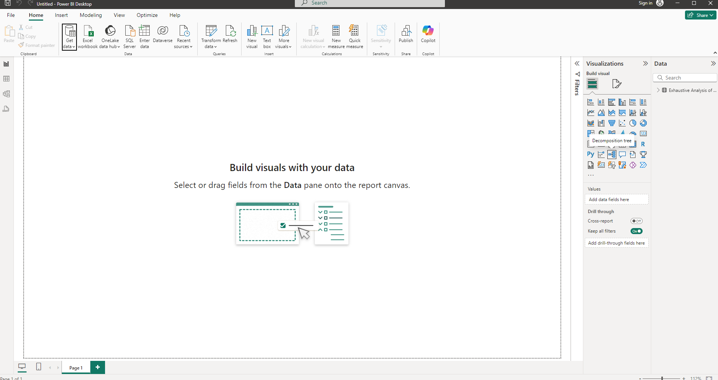

**Transform Data** :

* If the data needs cleaning or transformation, click **Transform Data**. This will open the **Power Query Editor**, where you can:
  + Filter, sort, and rename columns.
  + Split or merge columns.
  + Remove duplicates or errors.
  + Add calculated columns.
* 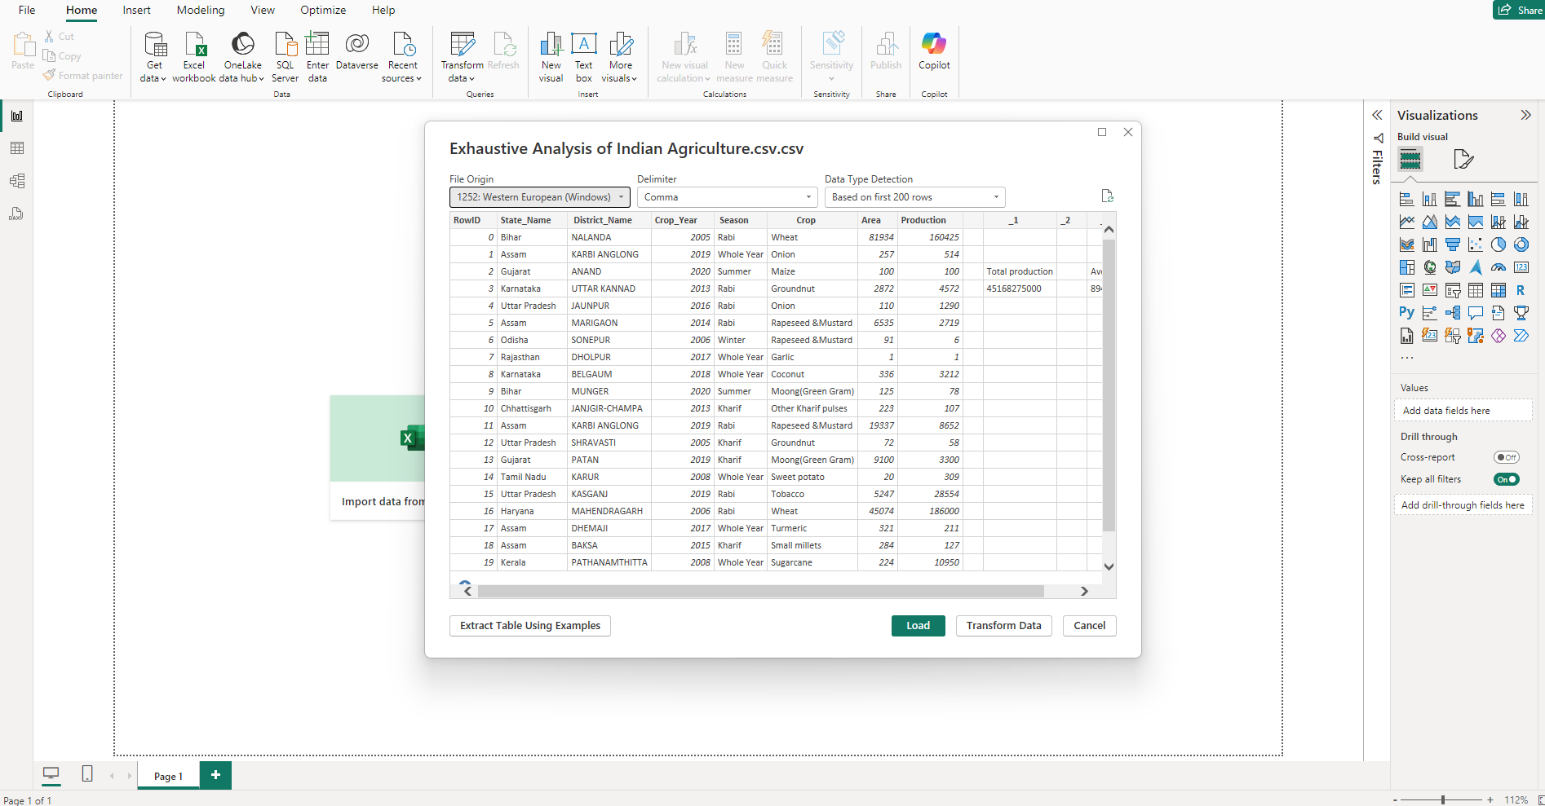

TABLE VIEW

The **Table View** in Power BI is a feature that allows you to view and interact with the underlying data of your dataset in tabular format. It is especially useful for verifying your data after loading or for identifying any data quality issues.

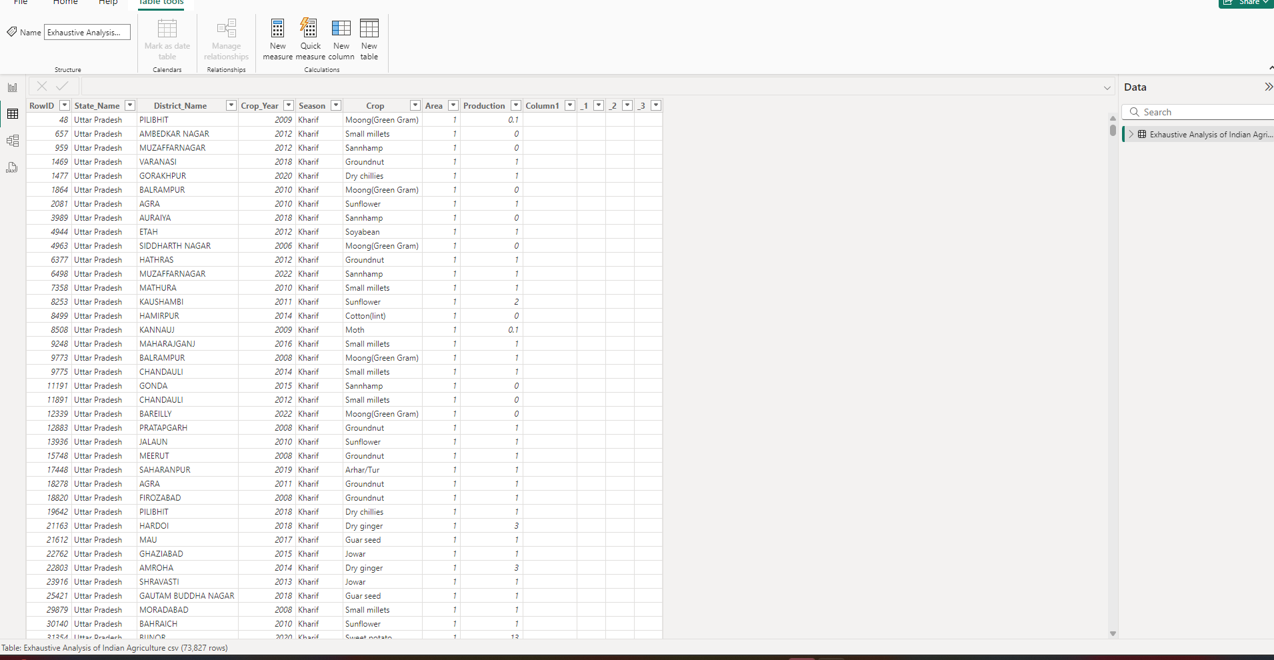

**Steps to Delete Columns in Power BI:**

**1. Open Power Query Editor**

* In Power BI Desktop, load your dataset.
* Go to the **Home** tab and click on **Transform Data**. This will open the **Power Query Editor**.

**2. Select the Column(s) to Delete**

* In the table preview within the Power Query Editor, locate the column(s) you want to delete.
* Select the column(s) by clicking on the column header.
  + To select multiple columns, hold **Ctrl** (or **Cmd** on Mac) and click the headers of the desired columns.

**3. Delete the Selected Column(s)**

* Right-click on any selected column header and choose **Remove** from the context menu.
* Alternatively, go to the **Home** tab in the Power Query Editor and click on the **Remove Columns** button in the ribbon.

**4. Apply the Changes**

* Once you’ve removed the unwanted column(s), click **Close & Apply** in the top-left corner of the Power Query Editor.
* This will apply the changes and load the modified data back into Power BI.

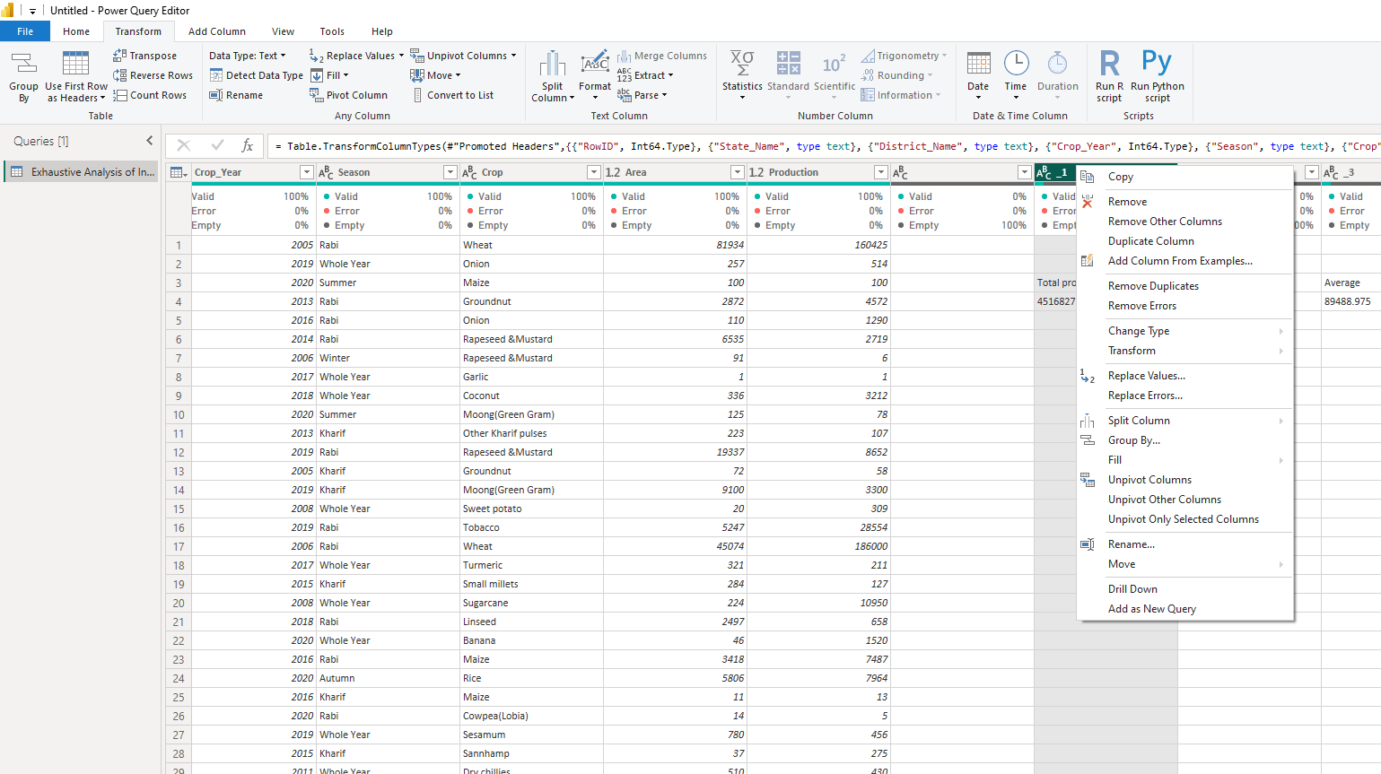

VIEW IN POWERBI

**1. Identify Null Values in the Data View**

* Navigate to the **Data View** (table icon on the left panel).
* Look at your dataset. Null values will typically appear as blank cells or the word null.

**2. Use Power Query to Highlight Null Values**

To show or filter null values using the ribbon:

1. Go to **Home > Transform Data** to open the **Power Query Editor**.
2. Select the column where you suspect null values. 3

